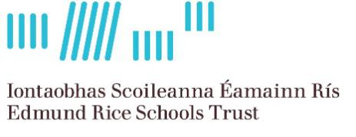

Coláiste Éanna
An Edmund Rice School

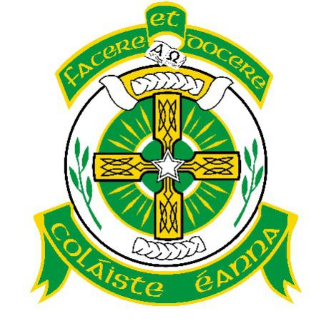

ANNUAL ADMISSION NOTICE
in respect of admissions to the 2024/2025 school year
Admission Policy and Application Form
A copy of the school’s Admission Policy and the Application Form for Admission for the 2024/2025 school year is available as follows: –
To download at: www.colaisteeanna.ie
On request: By emailing secretary@colaisteeanna.ie or writing to:
Coláiste Éanna, Hillside Park, Ballyroan Road, Rathfarnham, Dublin 16. D16 E248

PART 1 - Admissions to the 2024/2025 school year

Application and Decision Dates for admission to 2024/2025 school year
The following are the dates applicable for admission to First Year

The school will commence accepting applications for admission on | Monday 2nd October 2023
The school shall cease accepting applications for admission on | 4pm on Monday  23rd October 2023
The date by which applicants will be notified of the decision on their application is | Monday,  13th November 2023
The period within which applicants must confirm acceptance of an offer of admission is | 14 Days -  [i.e. 4pm on Monday,  27th November 2023]
*Failure to accept an offer within the prescribed period above may result in the offer being withdrawn
Note: the school will consider and issue decisions on late applications in accordance with the school’s admission policy.

Number of places being made available in 2024/2025

The number of places being made available in first year is | 120

PART 2 - Admissions to the 2023/2024 school year
Information regarding the admission process for the Intake Group for 1st year for the 2023/2024 school year

In respect of 2023/2024 school year, the total number of applications for admission received by the school for 1st year was 205
Breakdown of places allocated for the 2023/2024 school year:
Number of places available: | 112
Number of applications received: | 206
Number of Offers made and accepted under each criterion: | Criterion One: Brothers of students currently enrolled in Coláiste Éanna: 19 places offered, 18 places accepted.  Criterion Two: Students who have brothers who are past students* of Coláiste Éanna: 3 places offered, 3 places accepted.  Criterion 3: Sons of current full-time staff members: 0 place offered, 0 places accepted.  Criterion 4: Applicants from Ballyroan Boys N.S. and St. Mary’s N.S, Rathfarnham: 60 places offered, 33 places accepted.  Criterion 5: Sons of past students* of Coláiste Éanna, up to a maximum of 25% of the total places available: 12 places offered, 6 places accepted.  Criterion 6: Applicants from Primary Schools within the traditional catchment area that have established a tradition of sending boys to Coláiste Éanna.  The Rathfarnham Parish School, St. Colmcille’s S.N.S (Knocklyon), Scoil Treasa N.S. (Firhouse), Scoil Mhuire N.S. (Ballyboden), Edmondstown N.S., Gaelscoil Chnoc Liamhna N.S., Divine Word N.S., (Marley Grange), Rathfarnham Educate Together, Whitechurch N.S. (C. of I.) and The Good Shepherd N.S. fall into this category. 64 places offered, 24 places accepted.  Criterion 7: Applicants from other Primary Schools where a tradition as in Category 7 above, is emerging.  Holy Rosary N.S. (Ballycragh), Our Lady’s Boys’ N.S. (Ballinteer) and the Muslim N.S. (Clonskeagh), fall into this category. 6 places offered, 3 places accepted.  Criterion 8: Other applicants. 22 places offered 8 places accepted.  Late Applicants: 20 offered; 4 accepted.  * ‘Past Student’ refers to a student who has completed his full senior cycle programme in Coláiste Éanna.
Number of applications withdrawn | 0
Total number of offers made | 206
Number of names placed on waiting list for the school year concerned. | 0
Ratified by the Board of Management on 20 September 2023

